**NSSA Membership and Address Update Form**

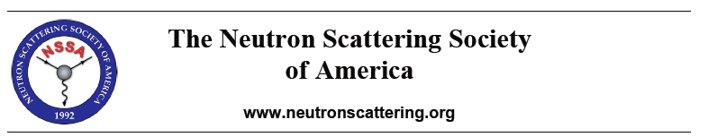

**New Member** □ **Member Information Update**□

|  |  |
| --- | --- |
| First Name |  |
| Last name |  |
| Title |  |
| Department |  |
| Institution |  |
| Street Address |  |
| City |  |
| State/Province |  |
| Zip/Postal Code |  |
| Country |  |
| Telephone |  |
| FAX |  |
| E-Mail |  |

**Area of Principal Interest (Select One):**

|  |  |  |
| --- | --- | --- |
| Biology □ | Chemistry □ | Crystallography □ |
| Engineering □ | Condensed Matter Physics □ | Fundamental Physics□ |
| Ceramics□ | Metallic Materials□ | Polymers□ |
| Other Materials Science □ | Instrumentation□ | Other □ |

**Details of Neutron Techniques Used or Other Area(s) of Interest**

|  |
| --- |
|  |